BCDE102 Introduction to Software Engineering -**Assessment Three - Portfolio**

**Final Iteration**

**Class Diagram:**

**Goal and Planning for the final iteration:**

**Goal:**

The goal for the final iteration is to bring together all of the iterations into one final project. This iteration is the one which will be presented to the client as the final project outcome. In this final iteration, a final class called Candidate will be added in the src folder along with Controller, Election, Electorate, and Party. There will be no changes being made to the styling from the previous iteration. However, the tables will be edited as seats, and vote percentage, will be added to the ‘Parties’ table. A new table called ‘Christchurch Central Candidates’ will also be added along with the candidate names, their respected parties, and their total votes sorted in a descending manner. All specrunner questions will also be added in this final iteration which will run via Jasmine. Following the patterns from the previous iterations, I will also create a directory named iteration5 which will still include all the necessary directories such as lib, spec, src, and style. As per standards, I will also include an index.html to enable the client to view the outcome of this iteration as well as a SpecRunner.html for the Jasmine unit testing framework to check for errors.

**Planning:**

The plan for the final iteration is to add and output all parties’ allocated seats and vote percentage as well as all candidates from Christchurch Central, their respective parties, and their vote count sorted in a descending manner. The output will be pass through the index.html file using a browser. I will also push all candidates to allMyCandidates and will output the result through the console.

**Analysis:**

This iteration is the combination of all previous iterations. This will serve as the finalization phase to the project. A class called Candidate will be added to the Election and it will serve as a vessel to allow another table to be added to the output. The Party and Election class will also be updated alongside the Controller to show the expected output on the browser.

**Design:**

No changes to the design will be made in this iteration. Only the tables will be altered to match the client’s requirements. All requirements should be fulfilled once this iteration is completed. The final iteration output as well as a sequence diagram will be included below.

**Coding:**

This final iteration should take 4 to 5 hours to complete as per specifications. The coding in this course was difficult to grasps at first as I had no prior experience in Javascript, HTML, and CSS but I was able to get through and learn a lot of things with the help of our tutors.

**Testing:**

For testing, I am using Jasmine for the framework. I have been using this framework for the past iterations and it works well for the purpose of testing. I have also incorporated all Jasmine test codes provided to us via moodle.

**Time Estimated and Actual Time Taken for each task:**

|  |  |  |  |  |
| --- | --- | --- | --- | --- |
| **Task** | **Task Details** | **Time Estimated** | | **Actual Time** |
| **Planning** | Plan for final iteration layout.  Formulate final iteration outcome. | 60 minutes   30 minutes | | 45 minutes  45 minutes |
| **Analysis** | Formulate which classes, attributes and methods to use. | 30 minutes | | 45 minutes |
| **Design** | Design the layout for the final iteration based on new specification. | 30 minutes | | 30 minutes |
| **Coding** | Output information on the browser and console. | 60 minutes | | 45 minutes |
| **Testing** | Test code to check for errors. | 60 minutes | | 75 minutes |
| **Total Time** |  | 270 minutes or 4.5 hours | 285 minutes or 4.75 hours | |

**Sequence Diagram:**

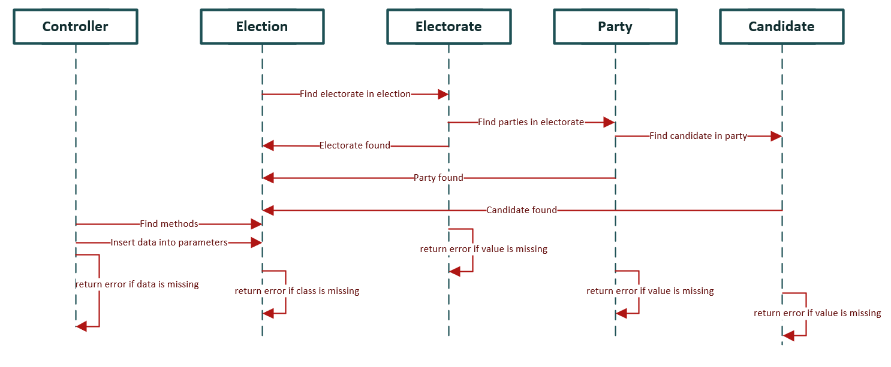

**Final Iteration Output:**

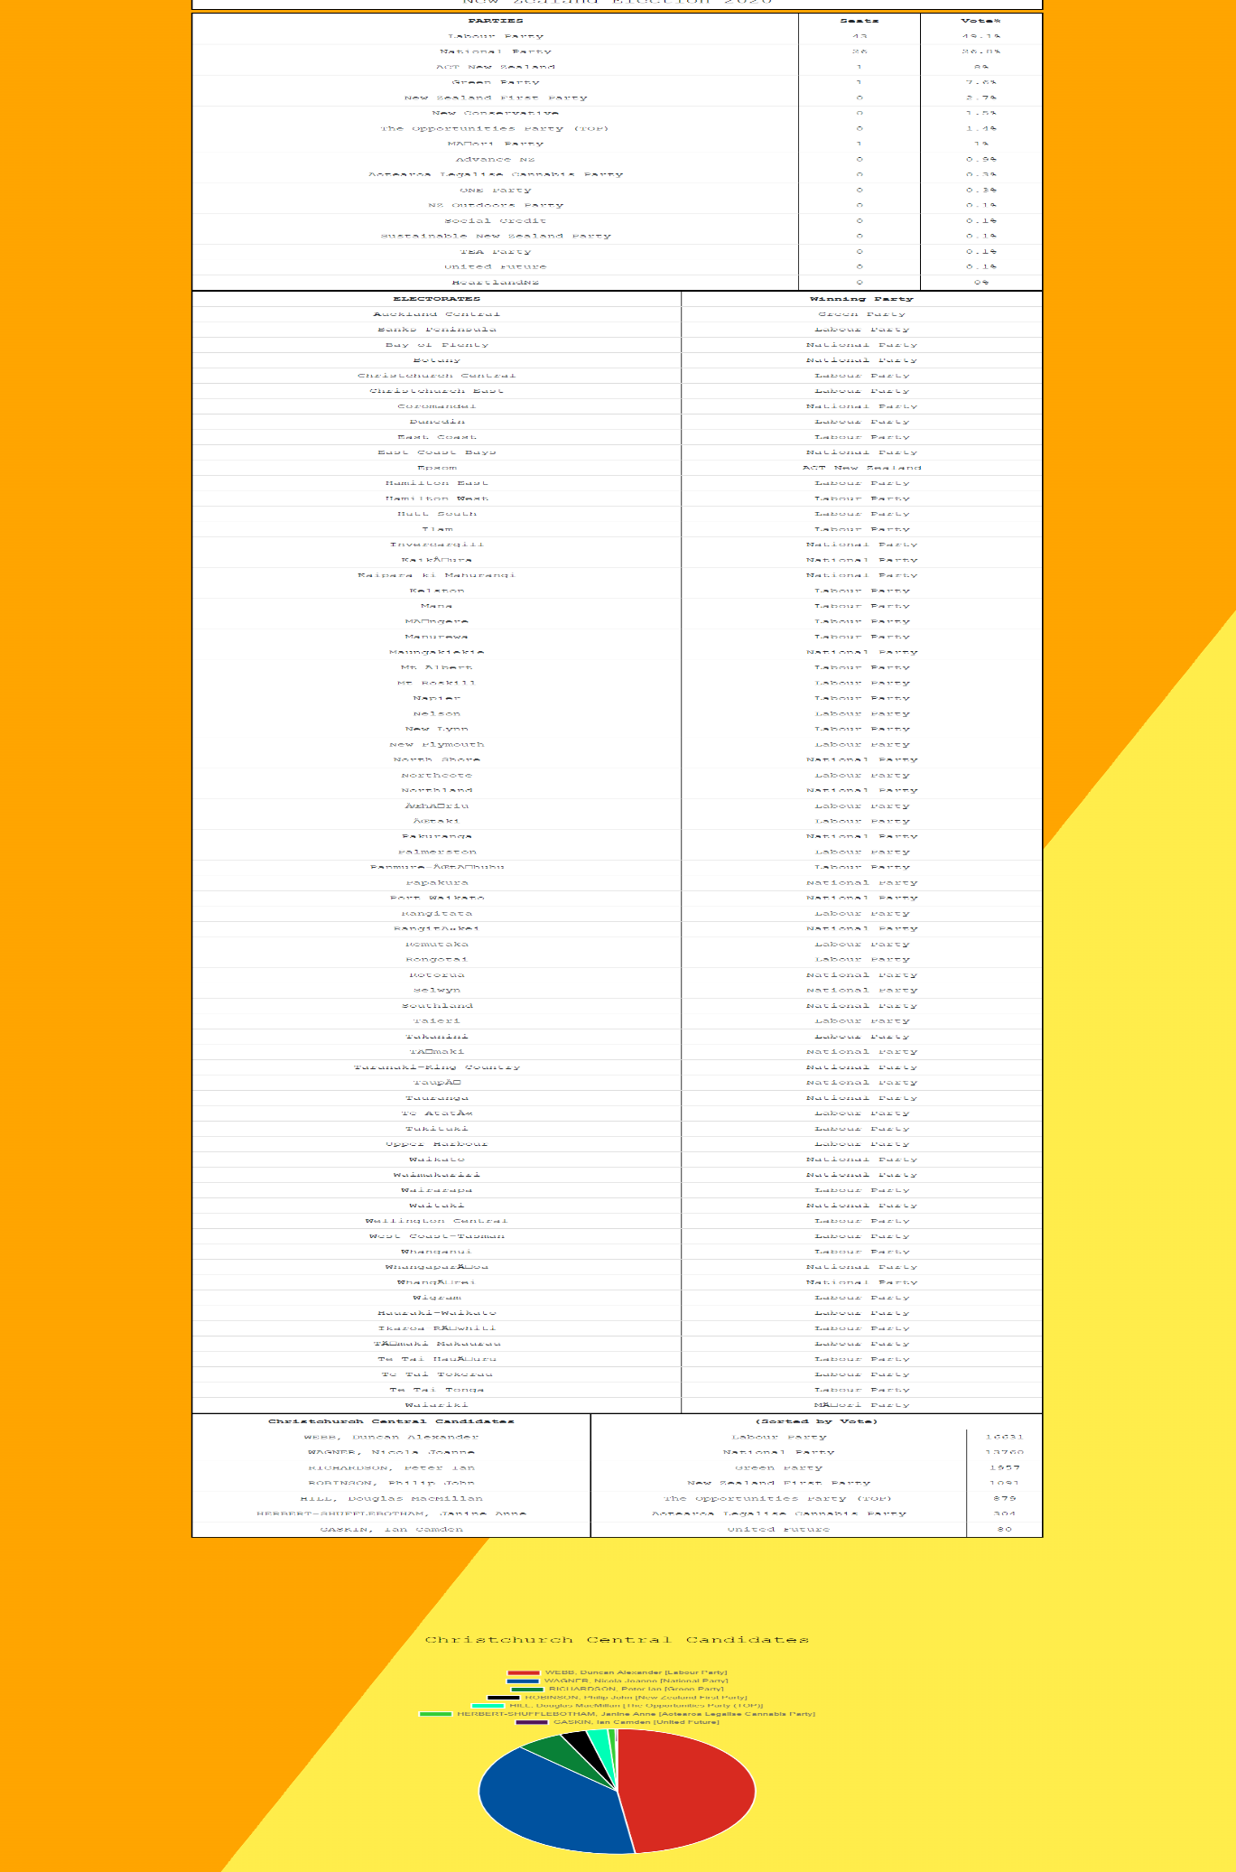

**Console result:**

**Jasmine Unit Testing:**

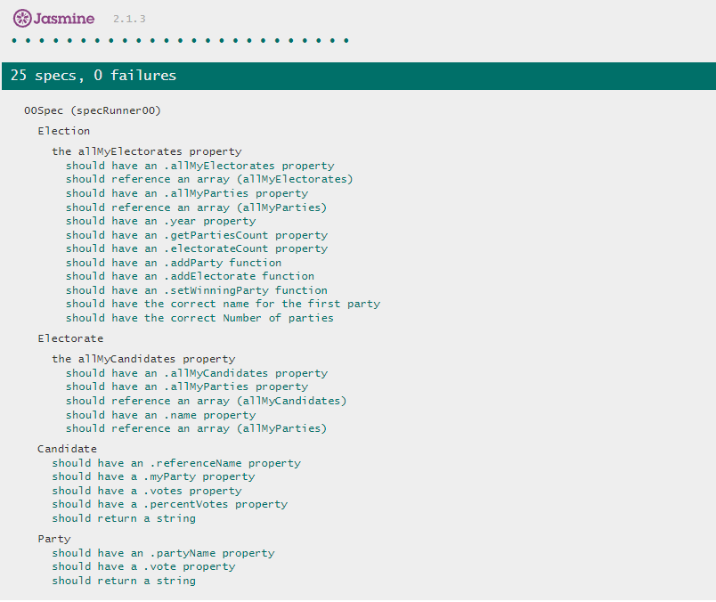

**Code checks:**

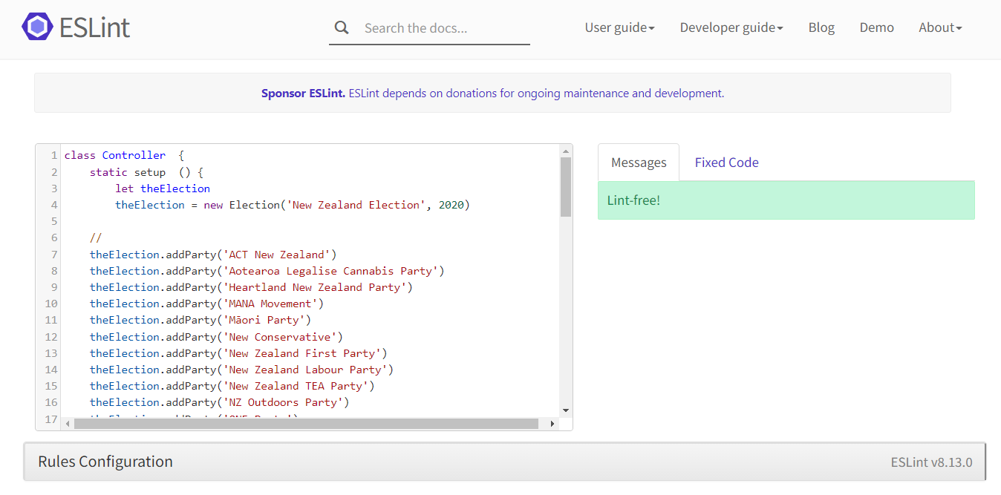

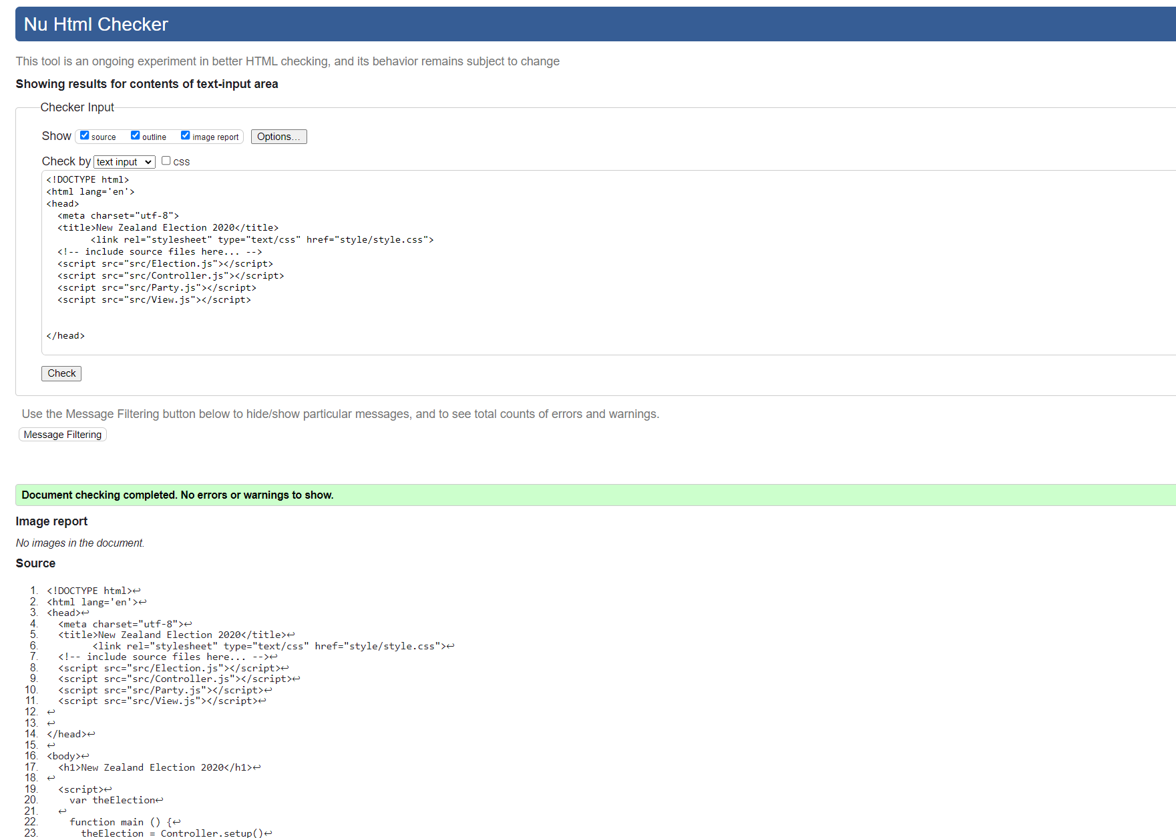

**What happened vs what was planned:**

Everything worked according to plan. No issues were encountered in the final iteration. This course has been very informative and I have enjoyed the challenges it has brought along the way.

**Performance Review:**

**What worked:**

Everything worked for this iteration. I have also used a sequence diagram for planning as I used packaged diagram for the fourth iteration. I have also added a pie chart of the Christchurch Central Candidates using bootstrap and enabled table hover. The user is now able to click on the candidate names and the pie chart will change accordingly. This iteration is the finalization of the assessment 3 portfolio.

**What did not work?**

No issue encountered.